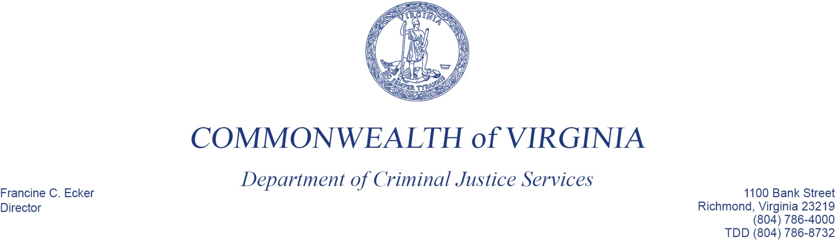

June 30, 2016

MEMORANDUM

To: The Honorable Terrence McAuliffe, Governor

From: Francine C. Ecker, Director

Through: The Honorable Brian Moran,
Secretary of Public Safety and Homeland Security

RE: Application for Federal Funds Available Through the Justice Assistance Grant Program

The Justice Assistance Grant Program (JAG) provides federal funding to the states and localities to support a variety of criminal justice system improvements. In accordance with the method for distributing funds specified in the JAG enabling legislation, some funds are to be awarded directly to selected localities by the federal Bureau of Justice Assistance (BJA) and some funds are awarded to the states for their use in making grants to state agencies and localities.

The Department of Criminal Justice Services is responsible for applying for and administering those JAG funds designated for Virginia that are not to be awarded directly to localities by BJA. BJA determined that DCJS is eligible to apply for $3,454,450 in federal fiscal year 2016 funds.

Our deadline for submitting the required application for these funds to BJA is June 30, 2016. JAG program guidelines require us to certify that we provided you with a copy of the application. As in the past, we are required to file the application online and, as a result, we are unable to provide in advance copies of those parts of it that consist of online forms to be filled-out at the time of submission. Essentially, they are the forms in which we will provide name and address information for the Department and assure that we will comply with various standard requirements that govern most federal financial assistance. We will be happy to provide you with copies of them when they are available.
June 30, 2016
Page Two

There are components of the application that we have prepared in advance and will submit electronically to BJA at the time we apply. I have attached them for your information: 1) a brief abstract that summarizes the application; 2) a Program Narrative describing our planning process and indicating in general terms how we will use the JAG funds; 3) a Budget and Budget Narrative; 4) the required Indirect Cost Rate Agreement; 5) documentation showing that we have satisfied JAG’s review requirements; 6) a statement that we do not have any pending applications for federal funds for the same projects to be supported with JAG funds; and 7) a copy of the required Financial Management and System of Internal Controls Questionnaire.

No action by you is required in connection with this application. However, if you or your staff have any questions about this material, or about the JAG program in general, please let me know.

